Alberto Martinez
CST 238
October 28, 2004

Comboling Detail

My previous detail of Combling described the rules associated with this program. This detail will go in depth on how the GUI will be constructed. Currently, I plan to implement the playing field of 10x10 tiles that are 24x24 pixels. This will provide a play space of 100 tiles and 240x240 pixels. There will be other buttons or methods of interaction that will start the game, modify game options, end the game, exit the game, restart the game and other option that may or may not be added as the game is developed.
The amount of tiles that will be in each level is determined by level + 1 tiles. The placement will be determined by a random “path” drawn on the board. The number of lines in the path will be determined by 1 path a level. So to visualize this I have included a diagram.
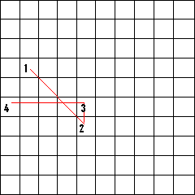

The path coordinates along with their order will be stored in memory until the puzzle is solved, since there is the possibility of multiple solutions, and will only be used if the user gives up or loses at which point the data will be used to show the user the solution.
My current plan for the tiles will be somewhat simple. A bitmap image for each tile “condition.” So, one bitmap for unused tiles, one for “raised” tiles and another for “pushed” tiles. Between each tile that is pushed will be a line showing the current path the user has chosen. The user will not be able to step back a move to make memorization a little bit more tricky. As time permits, animation will be used for path creation and tile selection along with sounds. For the graphics I am planning to use virtual DCs to open up the possibility of animation. The bitmaps will be resources included in the executable.

